1. Instead of bringing a holistic approach to education:

**A HOLISTIC APPAROACH TO EDUCATION**

1. Instead of Welcome to Bright Science Academy:

**BRIGHT SCIENCE ACADEMY**

1. Also can we use a different font? Something similar to the example website I showed you.
2. Video: Please cut the video to only the parts where **I’m shown, resources are shown and the backs of students**…cannot have the faces of clients on the website.
3. Add tutors association logo and royal society of chemistry logo (images attached to email)

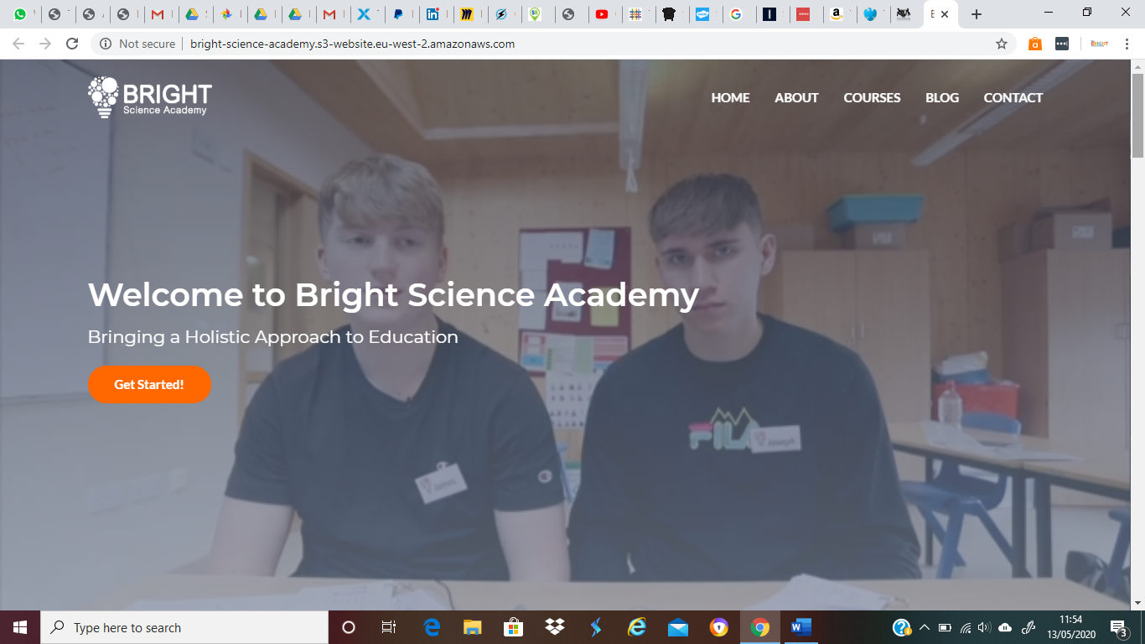

**Add:**

Testimonials

Resources

Academics | Emotional development | Critical thinking skills | Conflict resolution | Healthy social skills | Character formation | Manners

Please move the tag line under the logo

Testimonials:

Thank you so much. I couldn’t have improved without you pushing me to keep going and to think more positively. You have really made a difference to the way I look at not just Chemistry but all my other lessons. I have started to enjoy Chemistry as I am understanding it more and I couldn’t have done that without you.

* Student Z -

Thank you for today, J came home very upbeat and very positive about the session!

* Parent T -

I wanted to say thanks to you both too, T seems to be much more confident this year at school so the tutoring is having a knock-on effect there too and so much more.

* Parent L -

I liked the revision material and mind maps for topics, it really helped.

* Student H -

She really liked M and found him engaging, encouraging and clear. Thank you!

* Parent L -

We just wanted to say how happy we were to see the progress that J is making in Chemistry. We hear from chats and his work that he really enjoys his Science lessons, especially Chemistry. So thank you very much for the support you’ve given him so far.

* Parent T -